Eduan Van Der Merwe

PRACTICAL 8: VLAN IMPLEMENTATION AND NETWORK SEGMENTATION

Objective
Create VLANs and segment network traffic.

Equipment
- Cisco Catalyst 3560 Switches
- 10 PCs

VLAN Design

VLAN | Department | Devices
VLAN 10 | Administration | PC1-PC3
VLAN 20 | Lecturers | PC4-PC6
VLAN 30 | Students | PC7-PC10

Activities
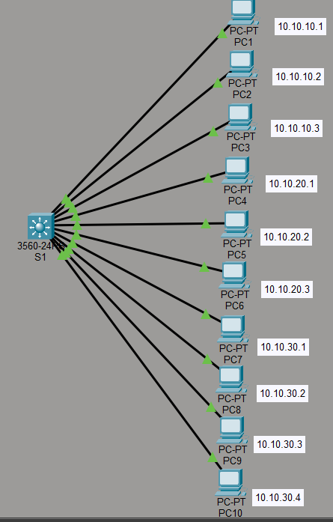
Figure 1: Full topology
- Create VLANs.
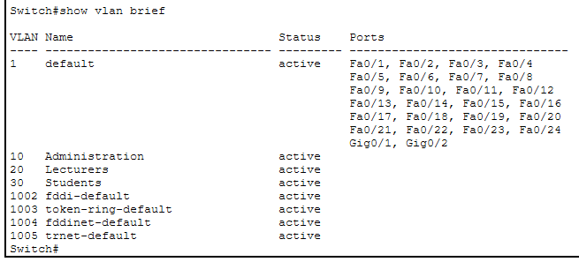
Figure 2: Vlan Config

- Assign ports to VLANs.
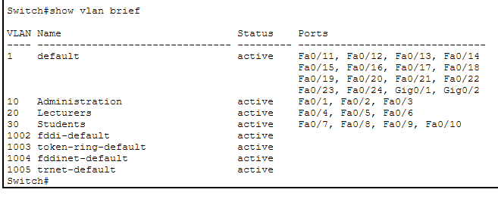
Figure 3: Vlan membership

- Verify VLAN membership.
- Test communication.
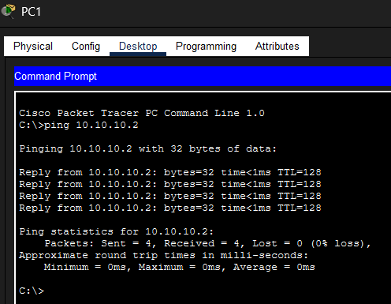
Figure 4: PC1 to 2
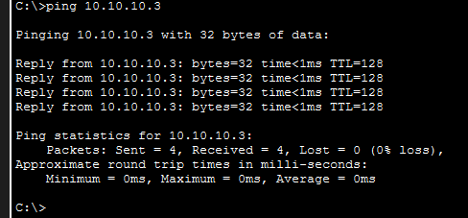
Figure 5: Ping PC1 to 3
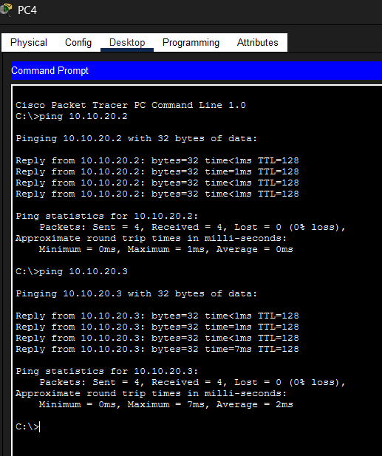
Figure 6: VLAN 20 connection
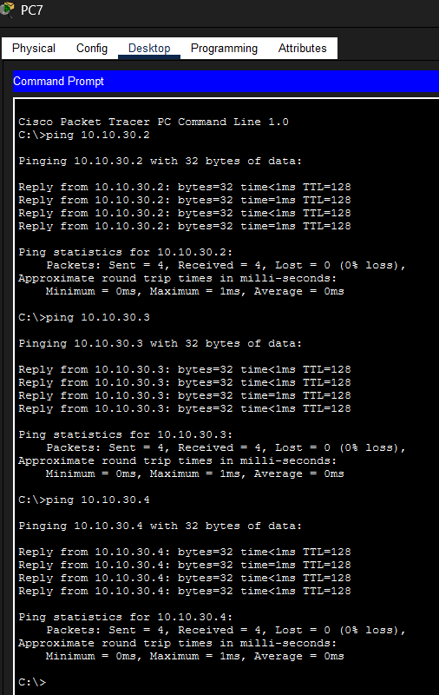
Figure 7: VLAN 30 connection
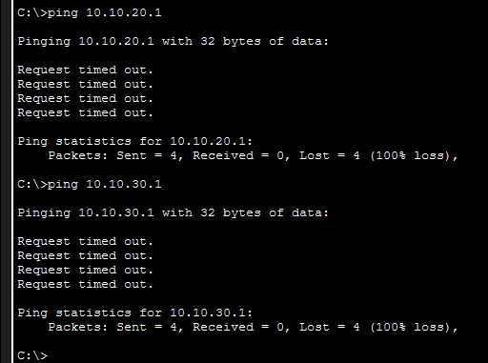
Figure 8: VLAN segmentation
- Document VLAN design.
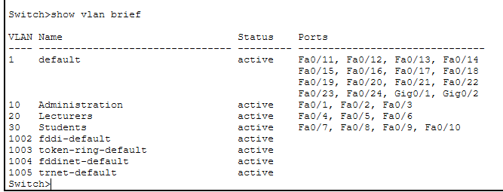
Figure 9: VLAN Verification

Example Commands
1
2
3
4
5
6
7
8
vlan 10
name ADMIN
vlan 20
name LECTURERS

vlan 30
name STUDENTS

Verification
1 show vlan brief

Deliverable
Working segmented network.

Assessment Rubric (15 Marks)

Criteria | Marks
VLAN creation | 4
Port assignment | 4
Connectivity verification | 4
Documentation | 3
Total | 15

